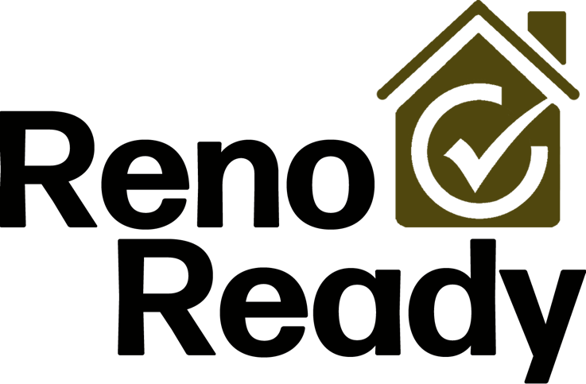

**User Testing Plan &**

**Discussion Guide**

Facilitator: Morgan Hall



**TESTING PLAN**

**Purpose and Objective:**

The primary purpose of user testing RenoReady is to ensure it lives up to its vision of empowering individuals in their DIY home renovation projects. To validate that the application is user-friendly, intuitive, and effectively meets the needs of its targeted audience ­– people undertaking small DIY home renovation projects. Testing aims to assess whether the app successfully aids in project preparation, budgeting, and task management while making the renovation process less confusing or daunting and more enjoyable as intended. User testing will identify any usability issues, functional problems, and areas for improvement. The overall objective is to obtain feedback and insights directly from the end-users, giving the opportunity to refine and enhance the app based on real-world experiences and expectations, thereby ensuring a successful launch and reception of RenoReady in the market.

**Testing Method:**

The testing method will include both controlled environment testing and guerilla environment testing. Controlled testing, where users will be invited into a structured environment to perform certain tasks, will allow for a systematic, in-depth evaluation of the app’s usability and functionality. It will offer the opportunity to carefully observe, measure, and analyze user interactions in a distraction-free setting, providing specific, detailed insights into areas of the app that may need improvements.

On the other hand, guerilla testing, carried out informally in a home goods store, enables us to capture feedback from potential users in a real-world context. This approach not only helps in collecting quick, spontaneous responses, but it also provides valuable insights into how intuitive and user-friendly the RenoReady app is for first-time users while also giving the opportunity to engage a broader demographic. Since home goods stores attract a wide range of individuals who could be potential users of the RenoReady app — from novice DIY enthusiasts to experienced home renovators — this method allows us to gather diverse perspectives on the usability and utility of the app. The combination of these methods helps ensure RenoReady is a robust, user-friendly tool that meets the needs of the targeted audience across various scenarios and usage contexts.

**Roles:**

RenoReady has need for only one role to be tested. This role will be the user testing the account creation, project creation, budget planning, and task management of a home renovation project. This requires users to create a project, determine a budget, add tasks, and manage those tasks. This also requires users to edit and delete projects as well.

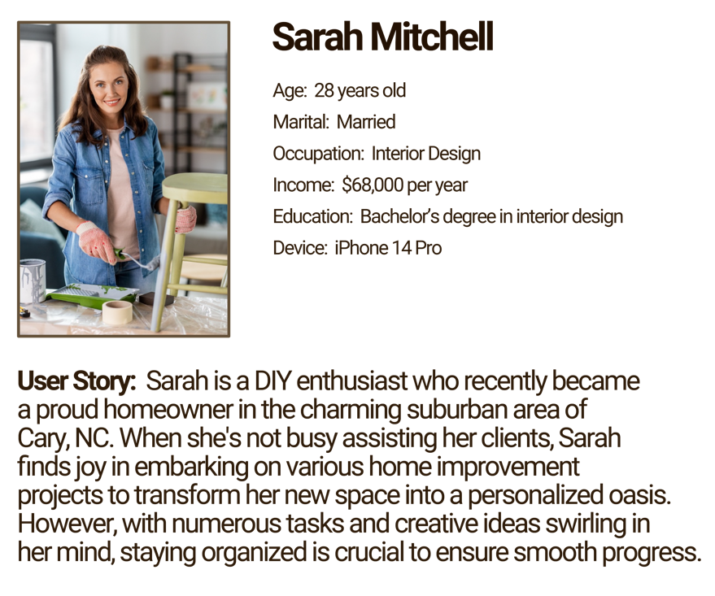

**TESTING PLAN**

**Number of Participants:**

5 participants

**Equipment:**

1­ – iPhone XS Max

1 ­– iPhone 14 Pro

1 – iPad

**Location:**

Local Home Depot

Top Quality Kitchen & Bath company office building

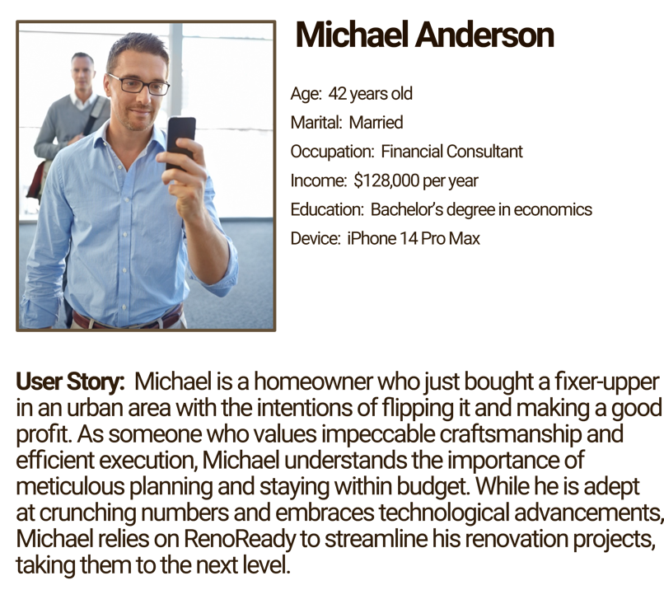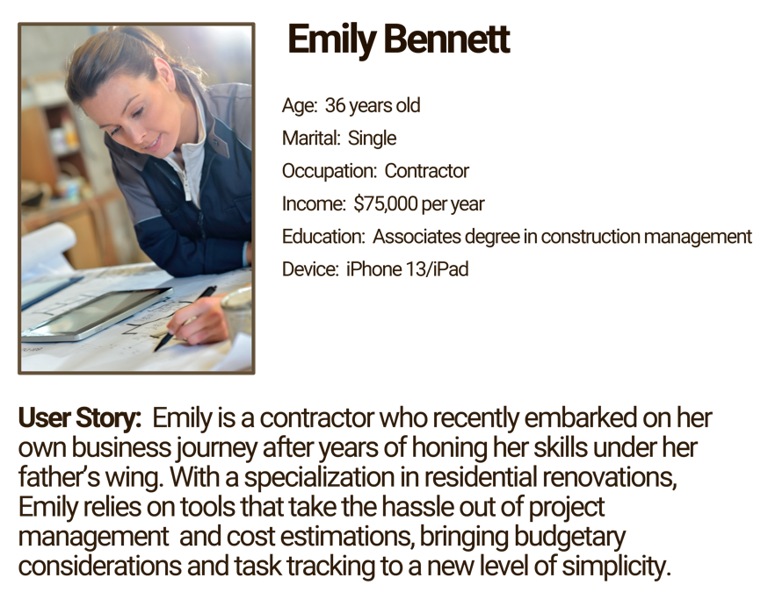

**USER PERSONAS**:



**DISCUSSION GUIDE**

**Introduction:**

Hello, my name is Morgan Hall. I am the creator of the RenoReady Application. I am looking for users to test the beta version of my application. This app is meant to be a project management tool for small DIY home renovation projects. Like redoing a kitchen before the in-laws come over for Christmas, or finally giving your child that bedroom makeover as they move up to middle school. RenoReady helps plan out the project details and break each project down into individual tasks while helping you manage and maintain your desired budget. The purpose of this test is to identify any usability issues, functional problems, and areas for improvement before releasing it onto the app store. Before we begin, I do need to ask you a few demographic questions to ensure that you are an ideal candidate for this app.

**User Research Survey Questions:**

1. What is your age?
2. What is your current occupation?
3. What is your annual household income?
4. Do you rent or own your own home?
5. How often are you redoing rooms in your home? (Very often, often enough, sometimes, occasionally, never)
6. How often do you *think* about redoing rooms in your home? (Very often, often enough, sometimes, occasionally, never)
7. What tools do you use when planning a room renovation or makeover? (Apps, websites, physical resources such as books, notebooks, planners, etc., or other)
8. How would you describe your level of comfort when using mobile devices, like your phone or a tablet?
9. Do you currently own an iPhone or an Android/Samsung mobile device?



**DISCUSSION GUIDE**

**Usability Testing Instructions**

1. Create an account.
2. Create a new project.
3. Create 4 new tasks.
4. Delete a task.
5. Save the project.
6. Mark 2 tasks as complete.
7. Edit a project’s name and budget.
8. Save the edited project.
9. Go to the Project Overview screen.
10. Delete the created project.
11. Go to your profile screen.
12. Change your profile picture.
13. Logout of your account.



**DISCUSSION GUIDE:** Follow-Up Questions

**Link to Survey:** [**https://3yfebgtzwka.typeform.com/to/lHwVYVqy**](https://3yfebgtzwka.typeform.com/to/lHwVYVqy)

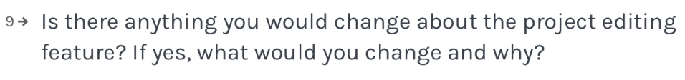



**DISCUSSION GUIDE:** Follow-Up Questions

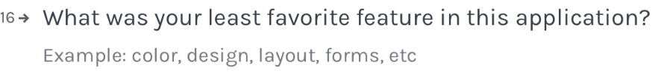



*Master Your Makeover, Manage with Ease!*